INDUSTRIAL REVOLUTION DBQ

You may refer to relevant historical information not mentioned in the documents.

Question: Evaluate the positive and negative effects of the Industrial Revolution.

Document 1
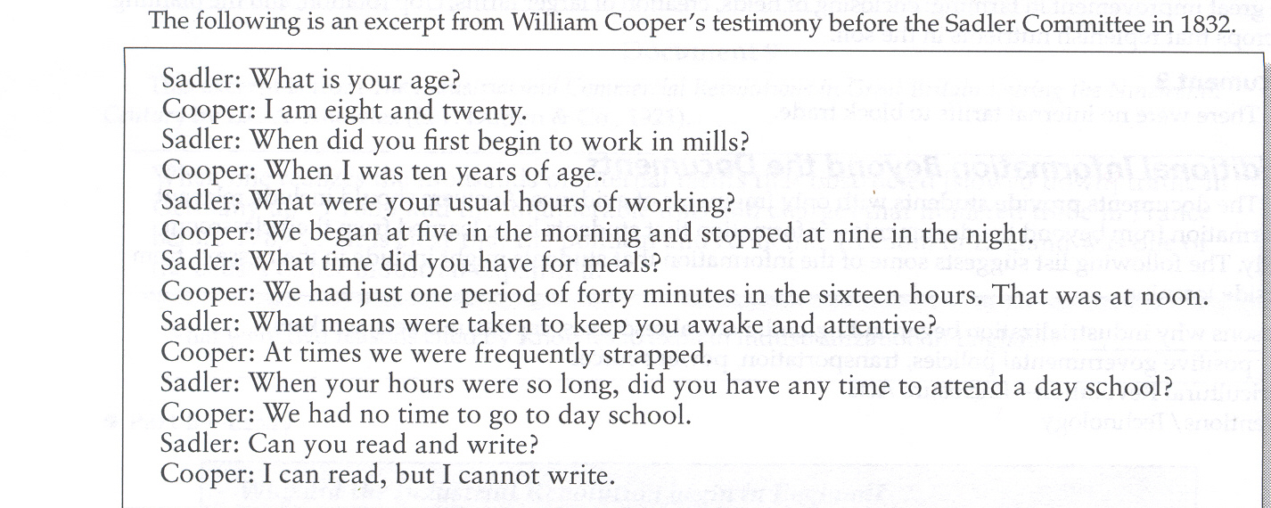

Document 2
“Contrary to the vulgar belief that men are motivated primarily by materialistic considerations, we now see the capitalist system being discredited and destroyed all over the world, even though this system has given men the greatest material comforts”
Ayn Rand (Russian born American Writer and Novelist, 1905-1982)

Document 3
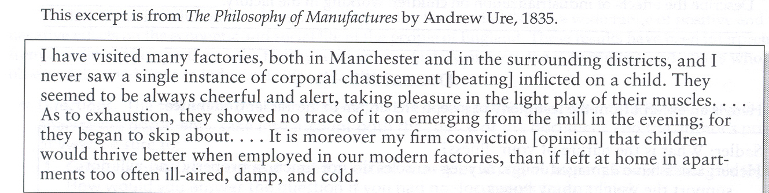

Document 4
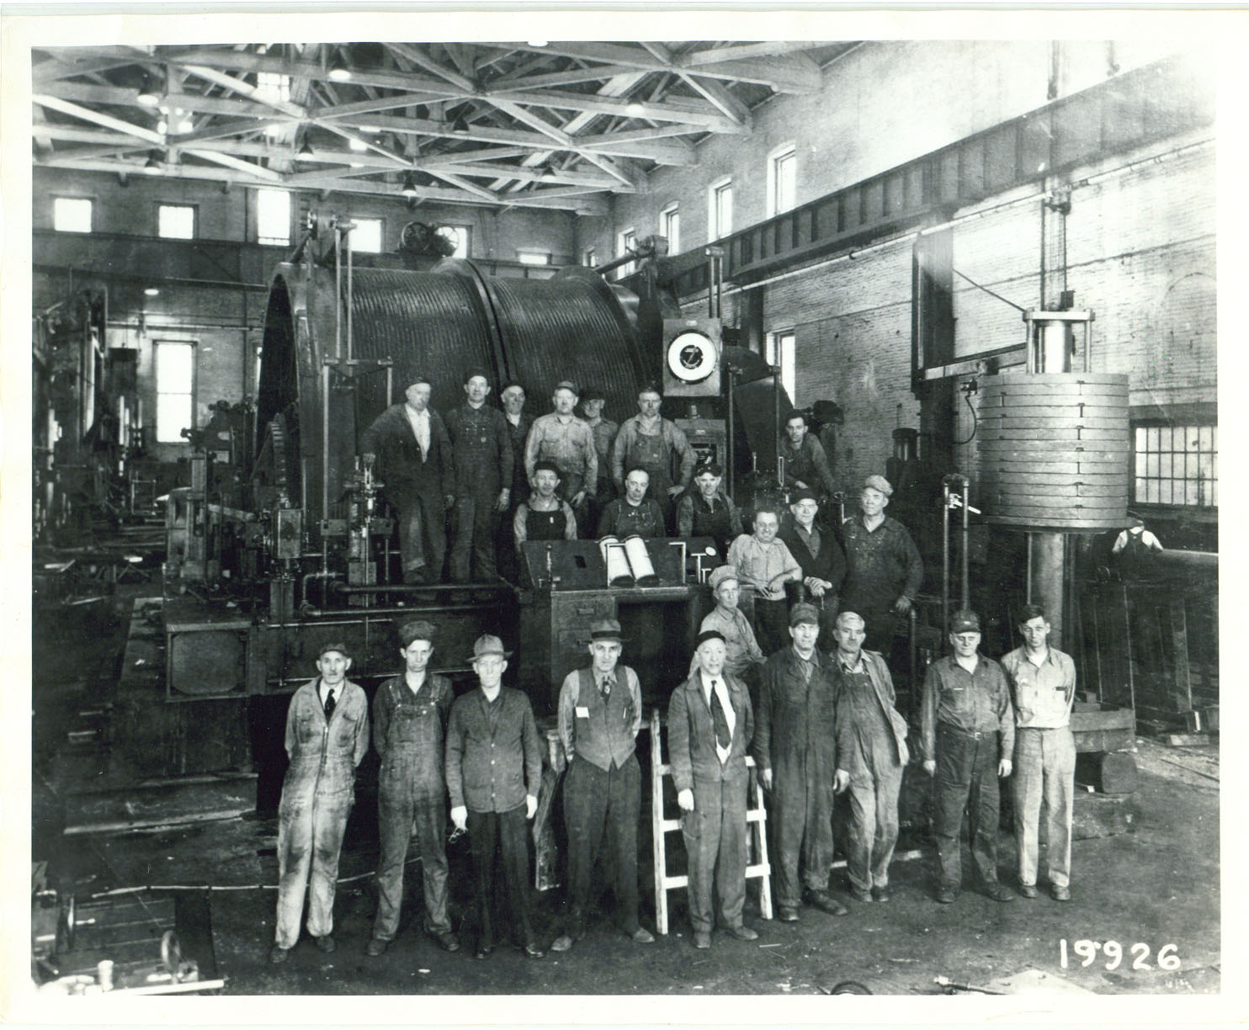

Document 5
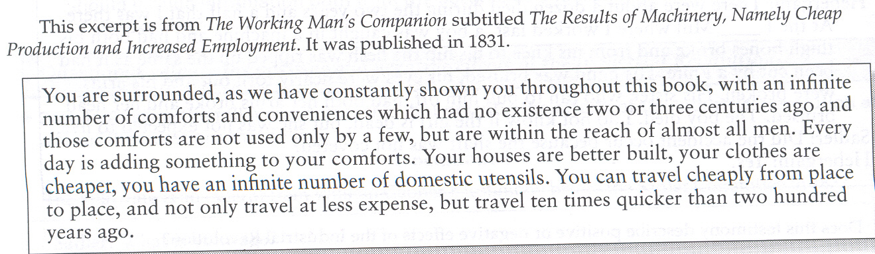

Document 6
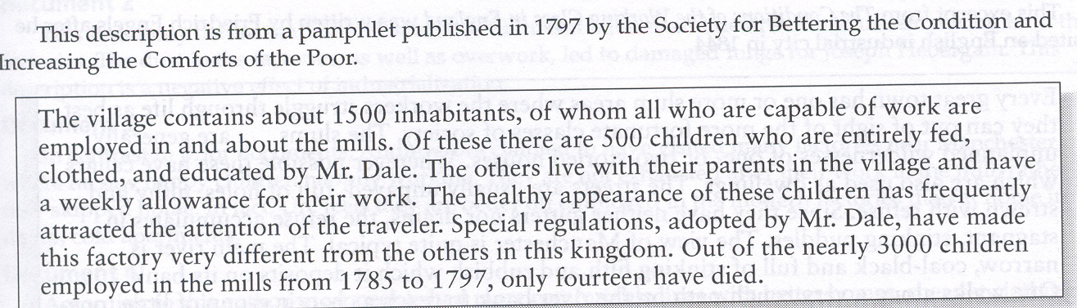

Document 7
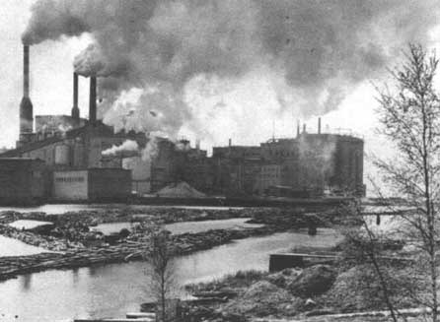

Document 8
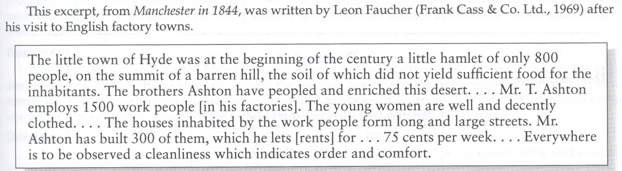

Document 9
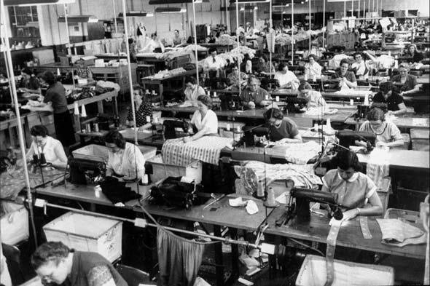

Document 10
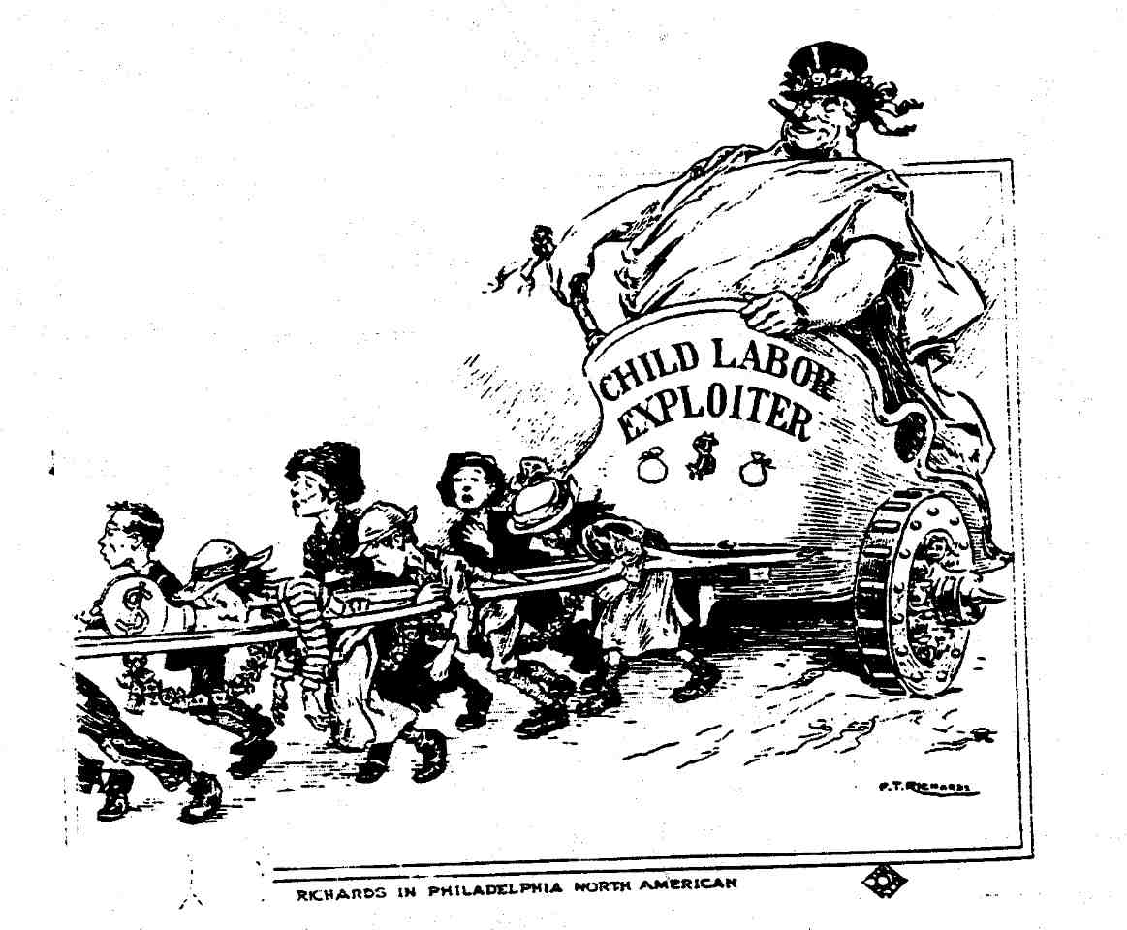

Document 11
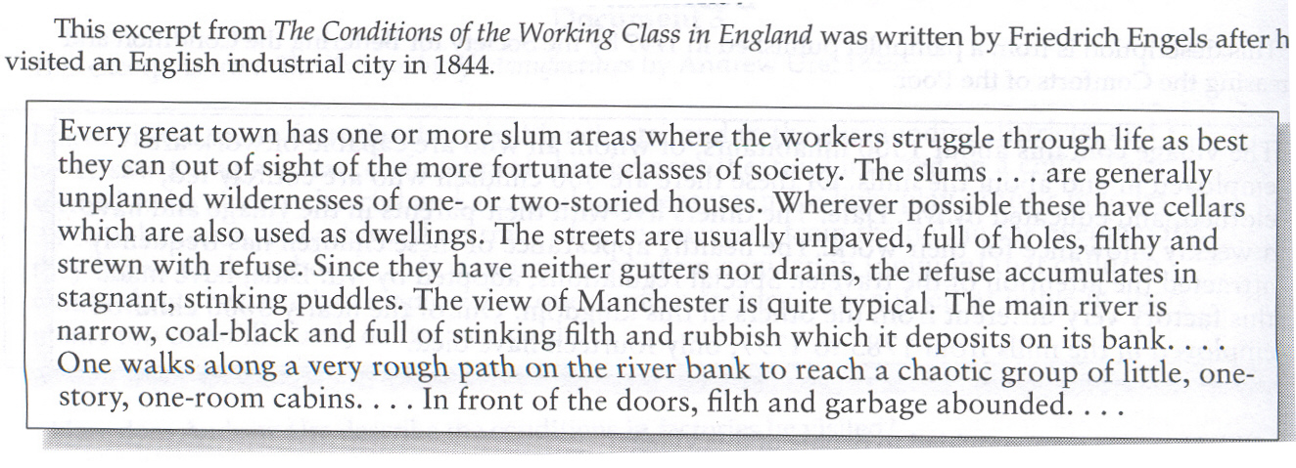

Document 12
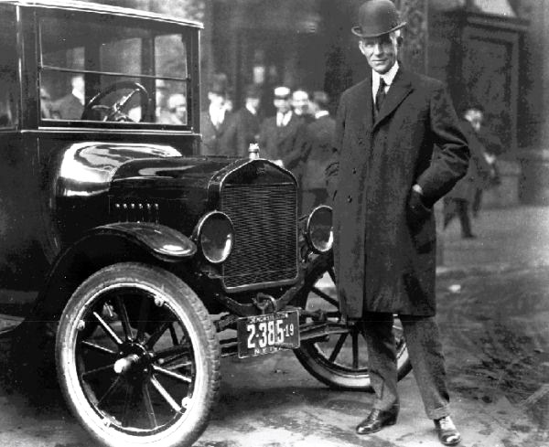

Document 13
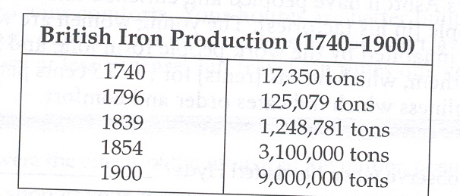

Document 14
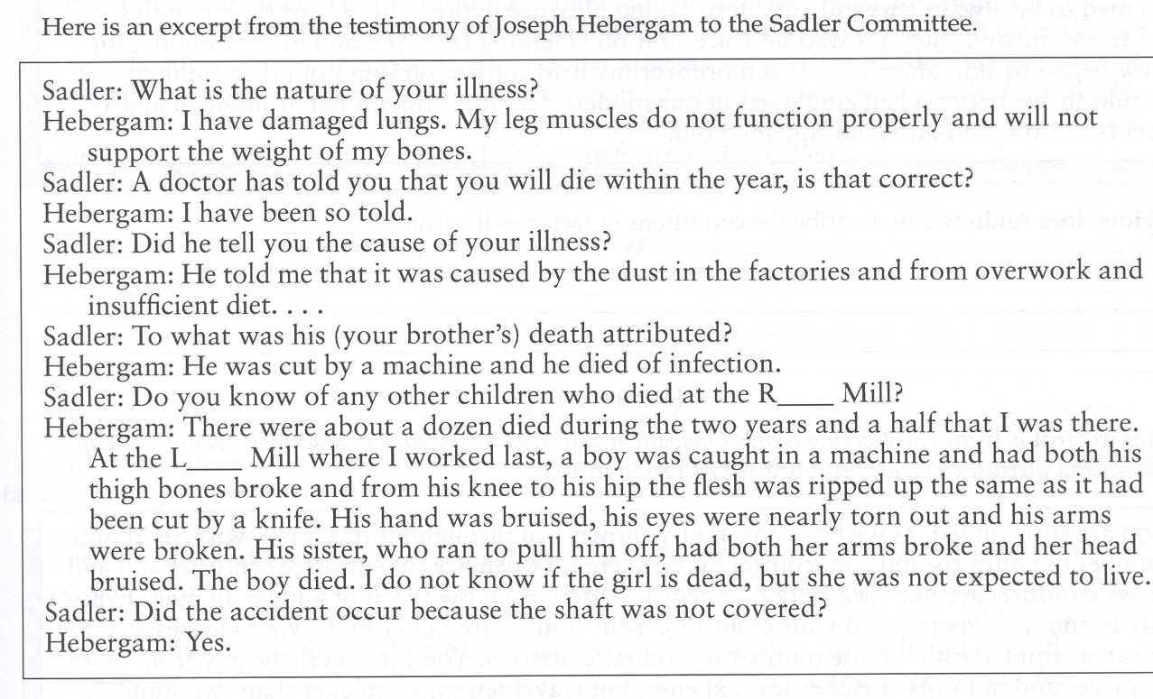

Document 15
