**Syllabus:** **English Language (ELL) Learner Class, Period 1 Teacher: Ms. Moore**

**cmoore@winthrop.k12.ma. us**

**Google Class Code: gn7qgbl**

**Materials Needed:**

***Folder, Blue / Black and Red Pens, Pencils & Eraser, and Highlighter***

**Couse Description and Expectations**

The ELL Class is a yearlong course. It has been designed to introduce students to the basic structures and vocabulary of the English language through the skills of reading, writing, listening and speaking in order to begin to function proficiently in the content-area curriculum.

The acquisition of language skills occurs as learners use English effectively in a variety of social and academic settings. This means that Multilingual Learners (MLs) need to actively participate in all activities that involve the use of English. Additionally, students will learn strategies in order to advance their reading, listening, and pronunciation skills. They will expand oral comprehensibility and write complete sentences, a standard paragraph, and short content-based essays. They will utilize level-appropriate conventions of grammar and punctuation with a minimum of errors.

**Goals:**

* Students will use English to interact in the classroom, and to communicate in socially and culturally appropriate ways.
* Students will interact with spoken and written English for personal expression and enjoyment.
* Students will use appropriate learning strategies to construct and apply academic knowledge.
* Students will use appropriate strategies to extend their communicative competence.
* Students in this class will be expected to demonstrate increasing competency in English

language skills in the areas of speaking, listening, reading, and writing, including the application

of grammatical conventions.

**Standards:** *There are five standards for each of the four domains (speaking, listening, reading, and writing):*

Standard 1: Social & Instructional Language

Standard 2: The language of Language Arts

Standard 3: The language of Mathematics

Standard 4: The language of Science

Standard 5: The language of Social Studies.

We will incorporate these standards into the context of our course work throughout the year.

**Policies for Success: Attendance, Deadlines, Work Ethic, etc.**

* For both teachers and students to be successful, it is necessary to have a calm, respectful, and productive classroom.
* It is important that you attend class, actively participate in classroom discussions, and complete all reading and writing assignments on time with a critical eye for *quality*.
* It is important to be on time, prepared, as well as organized.
* Maintaining tolerance towards different backgrounds or opinions.
* Doing your best, being positive and respectful to yourself and others will help you to succeed.
* Take responsibility for your learning and performance.
* Don’t shortchange yourself by wasting your time, wasting the time of others, making excuses, or cheating.
* Most importantly, ask for help when you need it.

**Assessment/ Grading/ Evaluation Practices**

* Your grades will be based on the classroom assignments, tests, homework and active class participation.
* Work missed because of an absence must be made up as soon as possible. If you need to make up a test, a quiz, or a class activity, see me as soon as you return to set up a time.
* Each assignment, quiz, class activity, or exam has a set number of points. All points are weighted equally.
* Late Assignments – are NOT acceptable. Your work needs to be turned in on time.
* All late assignments will be have 20% of full credit deducted each day they are late.
* You will have the opportunity for extra credit periodically. Please take advantage of these opportunities!

PLAGIARISM

Plagiarism is the practice of taking someone else's work whether written, a work of art, music, or ideas and passing them off as one's own. The WHS policy regarding this can be found on page 81 of the *Student Handbook,* and states:

“. . . Any student who cheats/plagiarizes on an examination, or any other assignment, shall receive a zero, and may not make-up such work. . . .”

Furthermore, the instructor, will then notify the parent/guardian, and will speak to the student privately about the issue.

THE VISION of the GRADUATE

Winthrop High School strives to ensure its graduates are able to become productive citizens of their town, their state, and their nation. To do this, the school in 2011 embraced the following learning objectives, on which students are evaluated quarterly. Taken together, they express a community vision for what we want our graduates to be, know, and do.

 WHS Students will become…

***Critical Thinkers***

·      They will use, apply, and evaluate multiple problem-solving strategies in a variety of

             disciplines.

·      They will be able to select, organize, and evaluate new ideas.

·      They will demonstrate the ability to actively and critically read.

·      They will develop the skills and acquire the knowledge necessary to prepare them for college and

career success

·      They will be able to set priorities, and manage their time and tasks.

***Effective Communicators***

·      They will communicate ideas and information with clarity and with an understanding

      of their audience.

·      They will integrate and use a variety of communication forms.

·      They will listen effectively and respond appropriately to spoken communication.

·      They will master standard English-language conventions.

***Conscientious Citizens***

·      They will be aware of, and follow, their community’s rules and laws

·      They will respect themselves and the community at large.

·      They will be aware of and respect social and cultural diversity.

·      They will understand, promote, and show the importance of hard work to achieve

      success.

·      They will own their mistakes, and will learn from them.

***Creative Achievers***

·      They will show curiosity and enthusiasm in everything they do.

·      They will work and think originally.

·      They will appreciate the arts in their many forms.

·      They will select, organize, and develop innovative ideas.

·      They will build off the ideas of others.

The *NEW* Cell Phone Use Policy, *Student Handbook,* pg. 79:

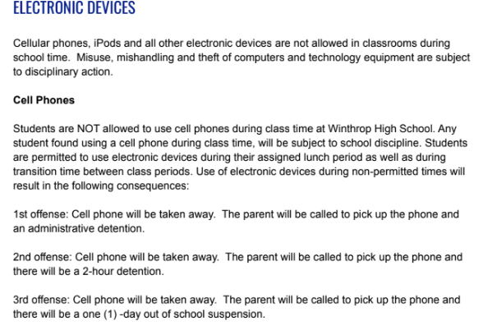

Finally, **WELCOME** to the English Language Learners Class! I am looking forward to working with you. I am here to help you do the best that you possibly can in this course. Do not hesitate to ask questions, and take pride in all that you do in class.

